The Road Home
Salt Lake Community Shelter and Self Sufficiency Center
Rapid Re-Housing POST-APPROVAL PACKET
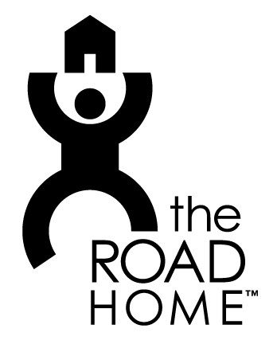
Congratulations on your approval for the Rapid Re-Housing (RRH) Program!
Here’s a list of reminders as you begin your search for your new home:

- LOCATION AND RENT REQUIREMENTS
  - Must be located in Salt Lake County
  - If approved for a Studio, the rent must not exceed $603.
  - If approved for a 1 Bedroom, the rent must not exceed $757.
  - If approved for a 2 Bedroom, the rent must not exceed $938.
  - If approved for a 3 Bedroom, the rent must not exceed $1351.
  - If approved for a 4 Bedroom, the rent must not exceed $1575.
  - REMEMBER, if utilities are included in your rent, they will be taken care of by the RRH program during assistance. If they are NOT, you will be responsible for utilities and any additional fees.
- APARTMENT SEARCH
  - Check in the Housing office regularly for new apartment listings/assistance in finding housing.
    - Open office hours 9-10:30 am and 1-2 pm Monday-Friday
- Find computer access to check online sites (Padmapper.com, KSL.com, Craigslist.org)
- Go to an area you would like to live/work in and walk around calling phone numbers listed on “for rent” signs.
- APPLICATION FEES
  - If an apartment you are interested in requires an application fee, fill out a request and return it to housing.
  - Application fees turned in between 9-10:30 am will be available the same business day at 2 pm; application fees turned in between 1-2 pm will be available the following business day at 10 am.
- INSPECTION
  - Once you have been approved at a unit, it must be inspected before you sign the lease and move in.
  - Notify housing or turn in an inspection request to the housing office and we will contact you when the inspection is complete.

