The Road Home
Salt Lake Community Shelter and Self Sufficiency Center
UNIT AVAILABILITY SEARCH TOOL
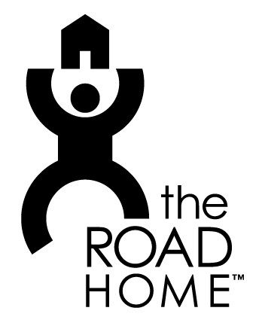
Hi, my name is and I am calling about your ad on (website, newspaper or sign) for the unit on .
Is that unit still available?
NO
Yes
Th Thanks so much, bye.

What is your application process?
“We have an application”
“Don’t have an application”
Is there an app fee?
“Is there a time I can come
see it?” “No” “Yes”

How much, what do you deny for?

“Case by case” “Evictions/
Felonies”

Voicemail:
Hi,
My name is and I’m calling about your ad on for the unit on . If that’s still available I’d love to ask you a couple questions about it. If you could give me a call back my number is . Thank you so much. Good bye.

